Time series analysis using MODIS satellite data in R

Yan Zeng

December 6, 2013

## Abstract

Vegetation indices can be used for global monitoring of vegetation conditions and display land cover and land cover changes. Sometimes it is difficult to detect the different class in single band imagery of NDVI. For example grass and cropland may have similar NDVI value range during summer. Time series NDVI can present the phenology characters based on time change. As the cropland has apparent grow season which make it easier to distinguish from grass in the Netherlands.

Keywords: time series, MODIS, Landover, R

## Introduction

In this paper we will focus on the analysis of MODIS satellite data. More specifically, we will look at the MODIS product called mod13Q1 which are global 16-day images with a spatial resolution of 250m.In this MOD13Q1 product one band is the MODIS normalized difference vegetation index(NDVI)products.

MODIS data was download via MODIS Global Subsets(<http://daac.ornl.gov/cgi-bin/MODIS/GLBVIZ_1_Glb/modis_subset_order_global_col5.pl>). The study area was located in Wageningen the Netherlands. Study area was located centred on: Latitude (52.004066410598504),Longitude(5.672054585039064) and encompassing the centre location 15 kilometres. Another data is the product of MODIS Landover Map showed in figure 1.

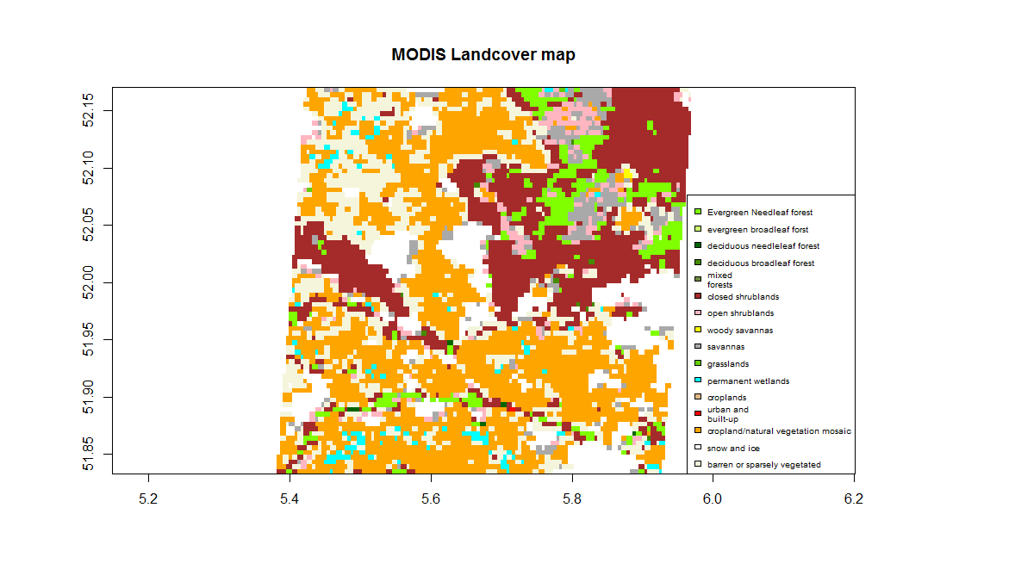

Figure 1,Landcove map of study area

Time series NDVI have more information about the phenology characters that how the land use change whole year. In this paper, histogram distribution of yearly mean NDVI and time series of different land cover are presented.

## https://mail.google.com/mail/images/cleardot.gifResults :

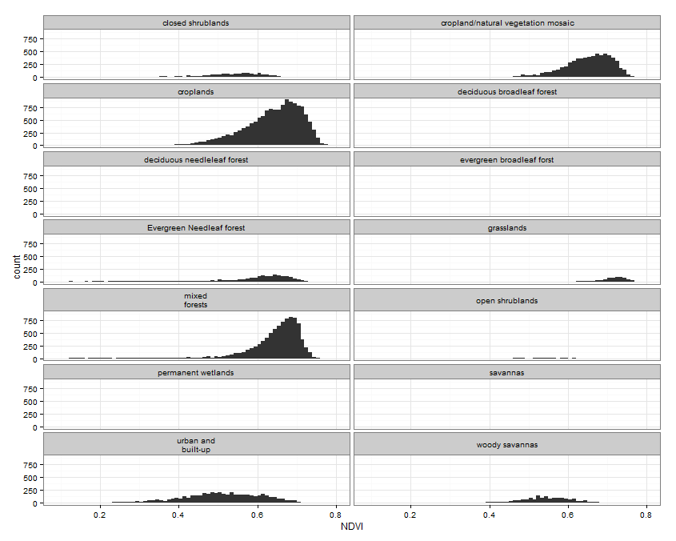Figure 2:Histogram of mean NDVI of year 2012 for different class

Figure 2 shows that cropland land/natural vegetation mosaic, croplands and mixed forests take the most potation in this area.

Grasslands has the highest mean NDVI than the other class. As in the Netherlands, grass land is always with a high NDVI during the whole than the other class.

Since urban has a low reflectance in NIR band, the value of NDVI of urban and build-up are ranged from 0.4 to 0.6. However, coarse resolution of MODIS make one pixel in not include just one class. For example, urban and build-up area are mixed with other vegetation.

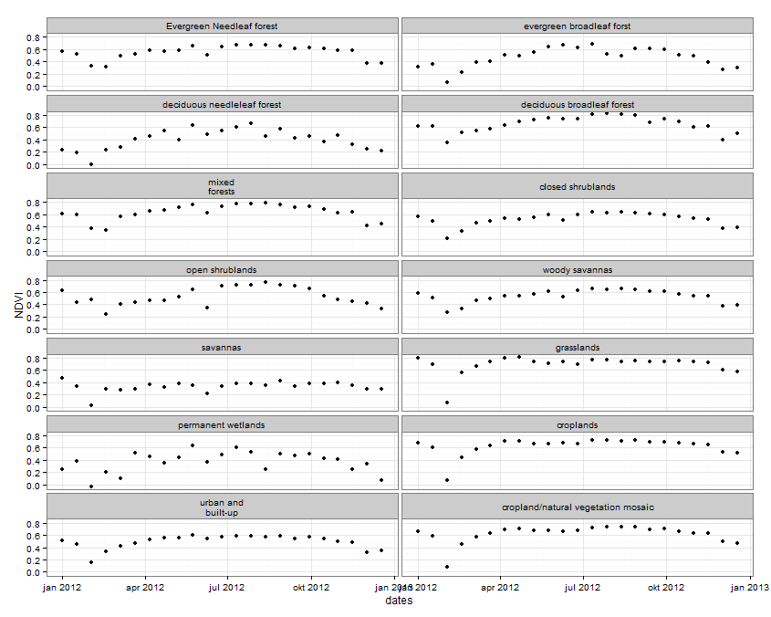

Figure 3:Time series of different class in study area

Figure 3 indicates the phenology characters of different land cover type in year 2012.The main different character can be detected from the start of the year. Mixed forests have a combination properties of evergreen and deciduous forest. It was surprised that the time series NDVI of savannas and permanent wetlands are more fluctuate than the other class

Comparing with evergreen needle leaf forest, evergreen broadleaf forest has a lower NDVI in February. Urban and built-up has lower NDVI than the other class.

## Conclusion

Phenology characters of land cover can present more information than single band of NDVI. Especially, when certain class does not account so many pixel in the image. If annual time series of NDVI images are used, the vegetation development (or plant phenology) can be determined. Because of this benefits, it can be used successfully for diverse applications, such as: Land cover classification, Hot spot detection, Plant phenology characterisation, Climate impact assessment. Therefore, Phenology characters can help to understand the characters of land cover more and also which can be used to make classification map.